Organization Chart Template

Example of an Organization Chart (uses Microsoft Word SmartArt)

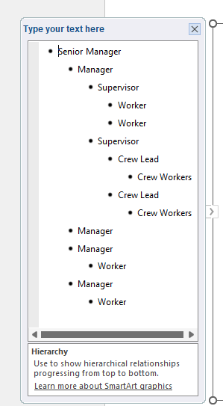
To create an organizational chart, begin breaking down the levels of authority in the organization. Start at the top and work through the levels of the reporting structure. The organizational chart will be important for developing the formal hazard assessments.
How To Use Template
Anything highlighted yellow should be updated to include company-specific information. As each organization is unique, please tailor these template documents to adequately represent the needs of your own organization.
(To remove the highlight in Microsoft Word, select the text SmartArt outer frame box and click on the Text Highlight Color dropdown and choose no color).
Save a copy of the file and delete the instruction pages when finished.
Microsoft Word includes a useful feature for creating charts called SmartArt. The rough template on the first page was made using this function.
To edit the chart, select it, then click on the arrow icon on the left side to open the text pane.
The bullets in the list correspond to the boxes in the chart. To demote an item, press Tab. To promote an item, press Shift-Tab. To delete a box, delete the item from the list. To add a new item, press the Enter key.

